Experiment -6

Name -Pranav Sandeep Raikar Batch -B

Div -D10A Roll no-43

A Execute the following scripts using grep /sed commands:

A.1)Write a script using grep command to find the number of words character, words and lines in a file.

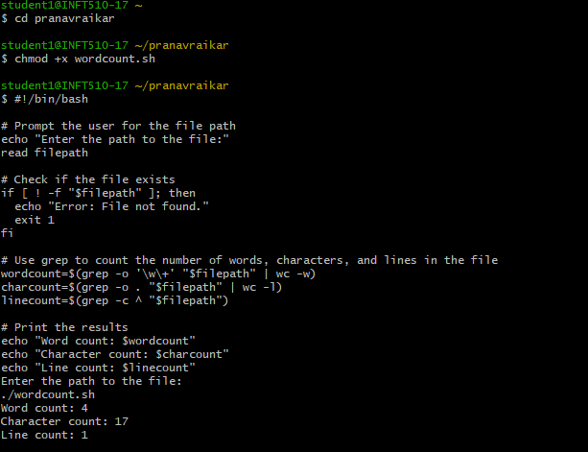

A.3)Write a script using sed command to replace all occurrences of particular word in a given a file.

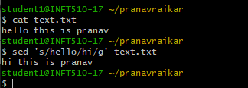

B.Execute the following scripts using awk/perl languages.

B.3 Write a perl script to sort elements of an array.

Code:

@n = (43, 56, 2, 78, 25, 65, 96, 1);

# Printing Original Array

print "Original Array: @n\n";

# Sorting numbers with use of

# spaceship operator

@x = sort { $a <=> $b } @n;

# Printing sorted array

print "Array after Sorting: @x\n";



B.4 Write a perl script to check a number is prime or not

Code:

#!/usr/bin/perl

print "Enter a number: ";

$n=<>;

$d=0;

if($n==2)

{

print "Prime number.n";

}

else

{

for($c=2;$c<=$n-1;$c++)

{

if($n%$c==0)

{

$d=1;

break;

}

}

if($d==1)

{

print "Number is not prime!\n";

}

else

{

print "Number is prime!\n";

}

}

